Presto User Guide

Last Updated: 10-Mar-2012

Quick Start Instructions 3

Overview 3

What is Presto? 3

The Deployment Process 3

What are the benefits of Presto? 3

The Pieces 4

What Presto Does 4

What Presto Doesn’t Do 4

Sample Setup and Deployment – Screenshots 5

Installation 12

RavenDB 12

Self-updating Service Host 13

Presto Task Runner 13

Presto Dashboard 13

Setting up Applications 13

Adding an Application 13

Task: Modify XML 13

Task: Copy File 13

Task: DOS Command 13

Importing Tasks 13

Exporting Tasks 14

Reordering Tasks 14

Assigning Custom Variables 14

Setting up Servers 14

Adding a Server 14

Associating Applications with Servers 14

Importing Applications 14

Exporting Applications 14

Assigning Custom Variables 14

Debug Logging 14

Custom Variables 15

Adding a Custom Variable Group 15

Importing Custom Variable Groups 15

Exporting Custom Variable Group 15

Adding Custom Variables 15

Installs Tab 15

Log Tab 15

Global Tab 15

Freezing Installations 15

Deployments 15

Initiating Deployments 16

Monitoring Deployments 16

# Quick Start Instructions

1. Copy the Presto Task Runner files (PrestoTaskRunner.zip) to a common location.
2. Install and run RavenDB (RavenDB-Build-573.zip).
3. Install and start the Self-updating service host (PrestoSelfUpdatingServiceHostInstaller.msi) on all servers that will be performing installations.
4. Install and run the Presto Dashboard (PrestoDashboardInstaller.msi)

# Overview

## What is Presto?

Presto is an automated deployment tool. It allows users to create deployment steps and then have servers update themselves when new versions of an app are ready. This allows for automated deployments to development, QA, and production environments.

The main reason to use Presto is when you have applications that need to be installed on many servers, in various environments, repeatedly, and each server requires a slightly different version of the app. That is Presto’s sweet spot.

## The Deployment Process

1. Within the Presto Dashboard, set up applications, servers, and variables.
2. When a new version of an application is ready to be deployed, copy the binaries to a common location.
3. Within the Presto Dashboard, initiate a deployment.
4. To deploy new versions of an application, go to step two.

## What are the benefits of Presto?

* Deployment is automated; manual error is significantly reduced.
* Logging
  + When users add an application to a server
  + When users initiate a deployment
  + Each deployment: server, application, start time, end time, result/status
  + Installation details of each task when Presto installs an app
* Flexibility: Variables are created and used by applications and servers
* Ease of use
  + Deploy an application (or many apps) to a specific server
  + Deploy an application to all servers within an environment (i.e.: QA)
  + Presto will update itself on all servers when a new version is available

## The Pieces

* **Presto Dashboard**: This is the application with which the user administers Presto. The user will create applications (and their tasks), set up servers, and create/use custom variables.
* **Presto Task Runner**: This is the actual deployment engine, running as a service on all servers. It polls the database to detect when an installation needs to occur, then performs the installation.
* **Database**: RavenDB (<http://www.ravendb.net>)

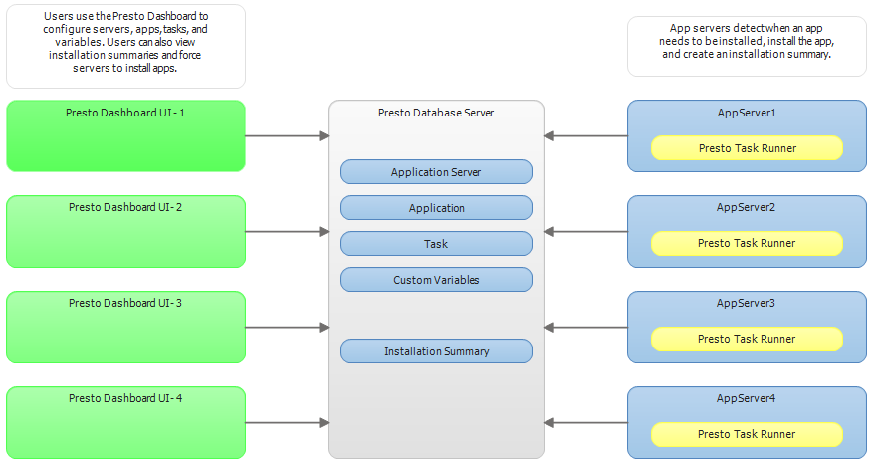

## What Presto Does

* Modify XML documents; usually configuration files
* Copy files
* Command prompt tasks. Examples:
  + Create a Windows service
  + Configure and start a windows service
  + Stop a clustered resource
  + Execute a batch file
  + Anything else that can be done at a command prompt

In a nutshell, Presto performs the three main tasks listed above. The power is in the third feature: command prompt tasks. Basically, anything that can be done at a command prompt can be automated with Presto.

## What Presto Doesn’t Do

* Deploy ClickOnce apps
* Deploy database schema and scripts

## Sample Setup and Deployment – Screenshots

Note: These screenshots are here for overview reasons, to see how things come together. For a comprehensive explanation of each of the steps, see the remainder of this guide.

Adding the application in the Presto Dashboard:

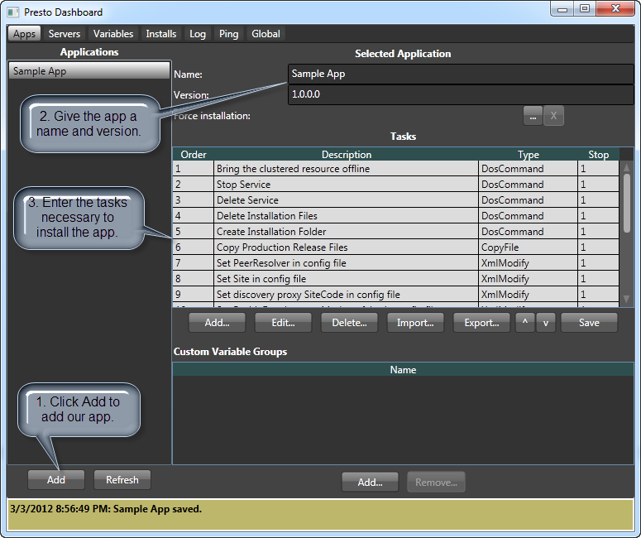

This is an example of one of the tasks (task 6 above, Copy Production Release Files). Here, we’re simply copying the app’s binaries from our production release folder to the installation folder:

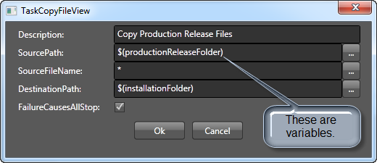

Note: Don’t worry about the variables. We’ll get to those below. That variable will resolve to whatever is set as the production release folder; something like: \\SomeServer\ProductionBuilds\SampleApp\Release\.

Now that we have our application, let’s create a server on which to install it.

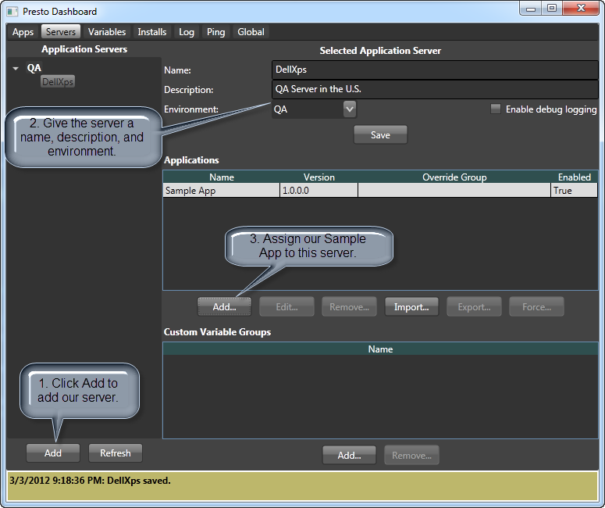

Before being able to deploy our app, we need to add our custom variables.

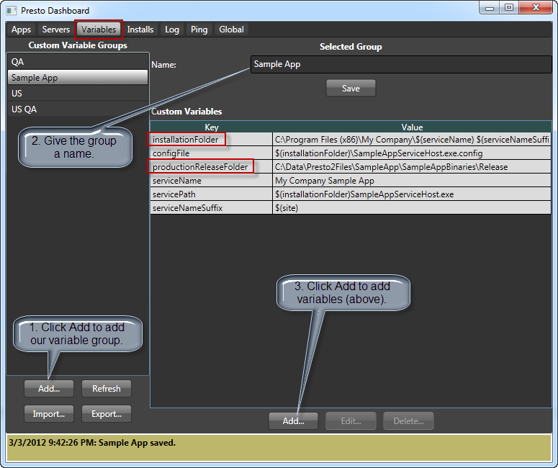

Remember our productionReleaseFolder and installationFolder variables from our task that we created a few minutes ago? This is where they’re defined.

Now we just need to assign our custom variables to the app and server. Here’s the app:

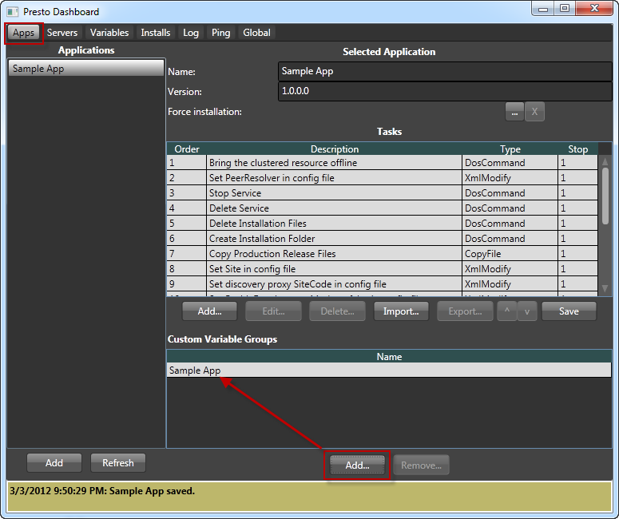

And here’s the server:

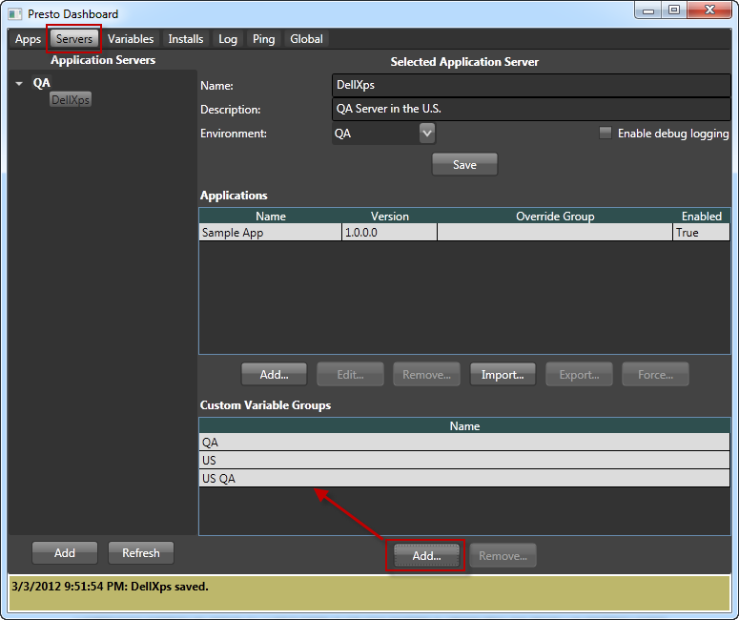

Now that everything is in place, all we have to do is initiate the installation. There are two ways to do so:

This will cause the application to be installed on all servers in the chosen environment:

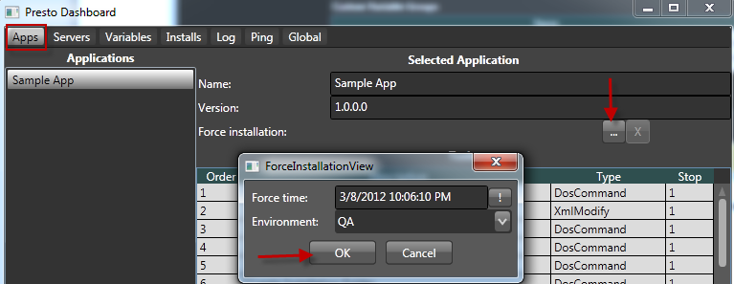

And this will cause the installation to happen only on this server:

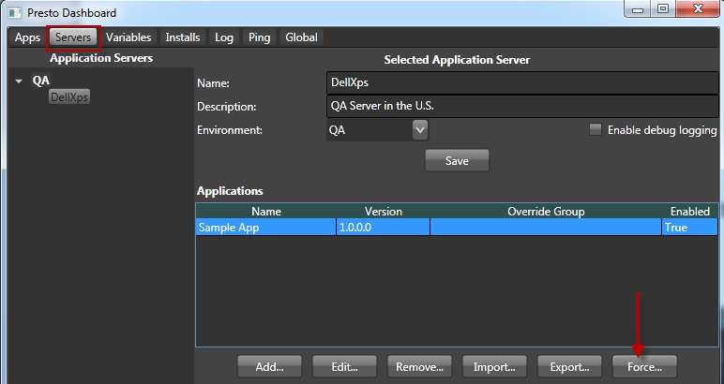

When the installation is complete, we can view the results on the Installs tab:

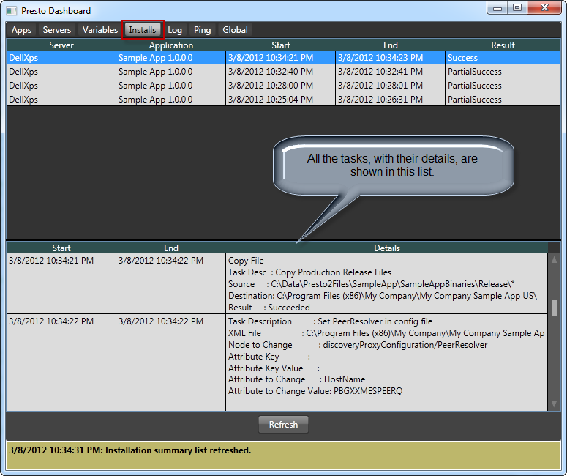

# Installation

## RavenDB

Presto currently uses build 573 of RavenDB, found here:

<http://builds.hibernatingrhinos.com/builds/RavenDB>

Download RavenDB-Build-573 and save it on the server’s (what will be your DB server) hard disk.

Unzip...

## Self-updating Service Host

The Self-updating service host needs to be installed on every server that will install applications that were set up in the Presto Dashboard. The job of this service is to detect new versions of the Presto Task Runner, shut down the current Presto Task Runner, copy the new files, and finally start a new instance of the Presto Task Runner. This allows for updates to the Presto Task Runner by just copying the new files to one location, and let all of the servers update themselves.

## Presto Task Runner

The Presto Task Runner (PTR) files need to be stored in one location, so the Self-updating Service Host can load it from this location.

## Presto Dashboard

Dashboard…

# Setting up Applications

## Adding an Application

## Task: Modify XML

## Task: Copy File

## Task: DOS Command

## Importing Tasks

## Exporting Tasks

## Reordering Tasks

## Assigning Custom Variables

# Setting up Servers

## Adding a Server

## Associating Applications with Servers

## Importing Applications

## Exporting Applications

## Assigning Custom Variables

## Debug Logging

# Custom Variables

## Adding a Custom Variable Group

## Importing Custom Variable Groups

## Exporting Custom Variable Group

## Adding Custom Variables

# Installs Tab

# Log Tab

# Global Tab

## Freezing Installations

# Deployments

## Initiating Deployments

## Monitoring Deployments